Ashcroft Public School Preschool Procedure
Emergency and evacuation
Reviewed: 2020 To be reviewed: 2021
Education and care services regulation/s | NSW Department of Education policy, procedure or guidelines | School policy or procedure
Regulation 168 (2)(e)  Regulation 97 | The following department document can be accessed from the preschool section of the department’s website;  - Emergency Management Procedures | Emergency Management Plan for Ashcroft Public School, May 2018
Procedures:
- This procedure should be read in conjunction with the school emergency management plan, developed by our school Health and Safety committee. This plan contains a preparation for emergency risk assessment.

- On commencement with the department, all employees must complete an online health and safety induction course.

- Displayed at each external exit are our evacuation, lockdown and lockout procedures and map (attached below). These procedures are also in the preschool casual folder.

- As part of their induction, casual and relieving preschool staff will have the location of these procedures highlighted.

- Next to each phone handset in the preschool, are local emergency contacts (also attached)

- All educators, children in attendance and the nominated supervisor will rehearse all emergency evacuation procedures (lockdown, lockout and evacuation) once a term, at both the start and end of the week, to ensure both groups of children have taken part in the rehearsals.

- A hardcopy record of these rehearsals is kept in a booklet, including an evaluation of the procedures, in the preschool kitchen.

- Our principal will also record details of whole school rehearsals (occurring once a semester) in the department’s In Case of Emergency (ICE) system.

- The preschool educators will develop (and review annually) a risk minimisation plan for emergency evacuations.

- A serious incident notification will be made to Early Learning on 9266 8165, who will inform our regulator, within 24 hours if there has been an emergency at the preschool that posed a risk to the health, safety or wellbeing of the children.
Ashcroft Public School

FIRE and EMERGENCY EVACUATION

In the event of an emergency the safety of students and staff could depend on the rapid and effective response to the following procedures:

- The signal to evacuate the building will be ONE CONTINUOUS SIREN.

- Once the signal has been given, staff who have students in their care (class, RFF, Library, support) should quickly follow evacuation procedures located at every exit point in every room.

- Staff should supervise all aspects of movement, taking particular care to ensure that all students leave the buildings.

- Once in the designated area all students are to line up in their roll classes as per assembly and rolls are checked. Any unexplained absences should be immediately reported to the Principal.

- Class teachers must closely supervise their classes until the emergency is passed. A general assembly will be called when the emergency is over.

- Under no circumstances should you dismiss your class from your supervision before this general assembly or unless directed to do so by the Principal.

EMERGENCY EVACUATION PROCEDURES
ROLES AND RESPONSIBILITIES
An emergency is declared by the Principal or designated officer.
Principal
- Sound alarm.
- Ring 000 and notify Fire Brigade/Police.
- Take mobile.
- Check staffrooms and community room (Block B) and Library.
- Move to assembling area and maintain order of all school staff and students.
- Liaise with emergency personnel.

Assistant Principals
- Check designated Block to ensure that all students and staff have left the building:

Mrs Ali – Block K, Block L, Block J, boys and girls toilets (junior) and Hall.
Mrs Holden – Block C, Block D, boys and girls toilets (senior) and GA Store.

- If not supervising students your responsibility is to support school in the evacuation assembling area and assist in keeping school calm.

School Administrative Manager
- Place evacuation sign on front door of Admin Block and lock door.
- Take mobile.
- Check Block A.
- Collect first aid kit.
- Move to assembling area.

School Administrative Officer
- Collect Emergency Evacuation Folder.
- Collect Staff Attendance Register.
- Collect Staff Early Departure Register.
- Collect Visitor Register.
- Move to assembling area.
- Distribute class lists to class teachers.

Teachers
- Evacuate students immediately on hearing signal – maintain calm.
- If safe to do so close windows and doors on departure from room.
- Take the Class Roll Details Folder (RED FOLDER) and be the last to leave classroom.
- Supervise movement – use correct pathway to assembling area.
- When class assembles ensure ALL students are accounted for this includes students who may be withdrawn by other staff.
- Mark roll and report any students not accounted for to Principal.
- Remain with class until directed to dismiss.

Preschool Teacher
- Evacuate students immediately on being notified – maintain calm.
- If safe to do so close windows and doors on departure from room.
- Take Staff Attendance Register.
- Take Arrival & Departure Register and be the last to leave classroom.
- Supervise movement – use correct pathway to assembling area.
- Mark roll and report any students not accounted for to Principal.
- Remain will class until directed to dismiss.

SACC Co-ordinator
- Evacuate staff & visitors immediately on being notified – maintain calm.
- If safe to do so close windows and doors on departure from room.
- Take Visitor Register and be the last to leave the room.
- Supervise movement – use correct pathway to assembly area.
- Line up ensuring all visitors are accounted for.
- Advise Principal of any persons missing.
- Remain in assembly area until directed to dismiss.

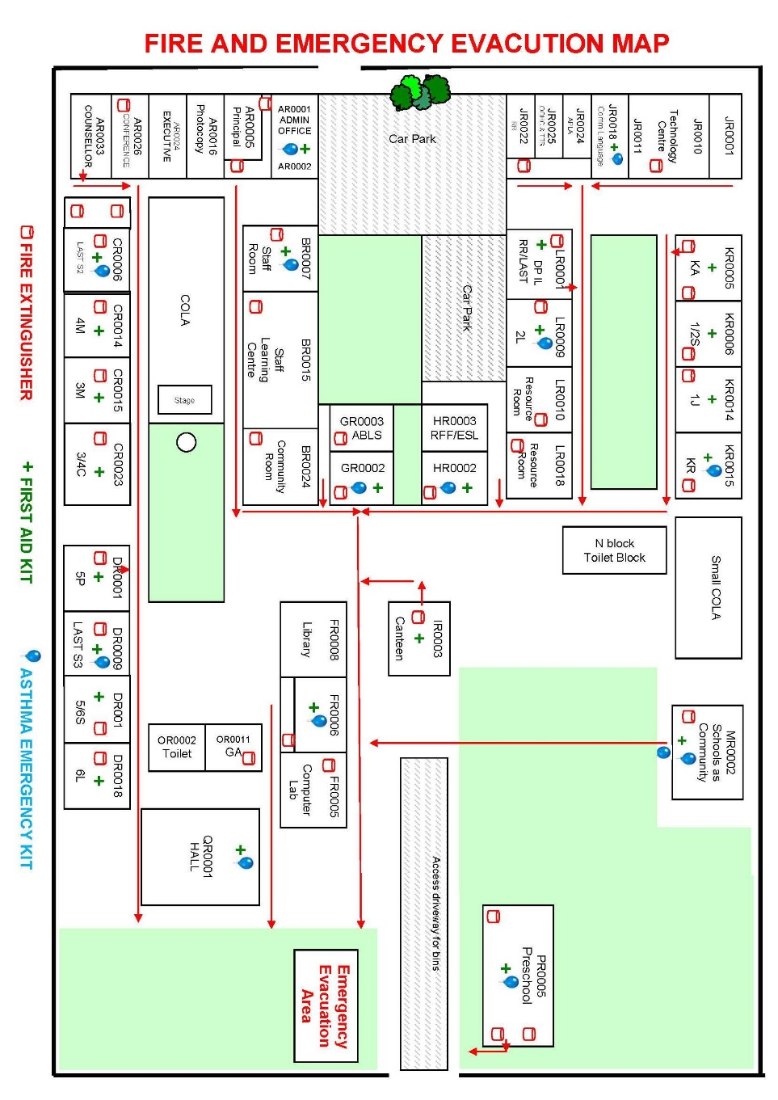
LOCKDOWN PROCEDURES
Lockdown is a procedure used when there is an immediate threat to the school e.g. school intruders. Lockdown minimizes access to the school and secures staff and students in rooms. As part of this procedure, everyone must remain in the room until the situation has been declared safe by an authorized person e.g. Principal or police officer.

Lockdown Procedures
- Should an intruder be identified, the staff member who identifies the intruder should immediately contact the principal or designated person who will determine if lockdown procedures should be initiated.
- Signal for lockdown will be announced over the PA to alert staff to lockout being activated, this will be followed by a short alarm.
- Principal or designated person should ring 000
- If safe to do so a designated person should wait outside the main entrance of the school to direct emergency services. Only authorised persons should be allowed access to the school.
- All outside activities should cease immediately. If any students are outside buildings, the supervising teacher should direct all students to the nearest appropriate school building.
- Staff need to lock all outside doors and windows. Ensure that all students are out of direct line of sight through windows and doors. Ensure that students are calm and quiet and seated on the floor.
- Staff should also quickly peruse outside their classrooms for any students outside to ensure all students are accounted for. Staff are not to leave classroom for any reason.
- Staff should record the names of students who are in the room. Any missing and/or extra students should be noted and this communicated to the principal or designated person as soon as possible. Contact will be made by the Principal or designated person to your mobile. When called use phrases such as ‘all here’; ‘missing John & Sue’; ‘extras here Penny from 2A, Steve from 1L’ etc.
- Staff should maintain room security and should not open doors for anyone under any circumstances.
- Students and staff should stay in the classrooms until official notification is provided by the principal or an identified police officer that the lockdown is over.
- Where the lockdown lasts an extended period of time or extends beyond normal school hours, the principal or designated person should notify parents in the most appropriate manner, with assistance of local police.
- In conjunction with local police, the principal or designated person should arrange for parents to pick students up from school at a designated safe area.
LOCKOUT PROCEDURES

Lockout is a procedure which prevents unauthorised persons from entering the school and is commonly used when the threat is general or the incident is occurring off the school property. This procedure allows school activities to continue as normal during the outside disruption.

Lockout Procedures
- Signal for lockout will be announced over the PA to alert staff to lockout being activated, this will be followed by a short alarm.
- If students are outside when lockout occurs, the Principal or supervising staff should direct students who are in the playground or outside school fences to immediately return to the closest appropriate building.
- The principal, or delegated person, should ensure all perimeter fences are secured.
- School routines are to continue functioning as per normal in classrooms. During recess and lunchtime Wet Weather Roster will be in place. No students are to be outside classroom unless there is a need go to the toilet.
- The only entry to the school for the period of lockout will be through main entrance and this will be monitored by Principal or designated person to ensure only AUTHORISED personnel have access.
- All clear signal will be given by Principal once lockout has ended. This will be announced over the PA.
- The Principal will liaise with NSW police or emergency services to implement plan for departure of students should the incident still be continuing at the end of the day.

FIRE EXTIGUISHERS – LOCATION AND USE

The Evacuation Map shows the location of fire extinguishers within the school.
Attempts to fight the fire should only be made if:
- Precautions for the safety of ALL persons has been taken.
- The fire is not too severe.
- At least two teachers or staff members are available to work together.
- The type of portable extinguisher or hose is appropriate to the type of fire.
Emergency Contact Numbers

NAME | NUMBER
Emergency – 000 | Ashcroft Public School Preschool - 9607 8202  Address: Carpenter Lane Ashcroft  Nearest cross street: Sinclair Road
Interpreter Service | 131 450 Quote Client Code.: C018294
Police – Green Valley | 9607 1799
Police Assistance Line | 131 444
Fire Station – Busby | 9607 6270
Liverpool Hospital | 9828 3000
First Care Medical Centre | 9826 7555
Poisons Information | 131 126
NSW Food Authority | 1300 552 406
NSW Public Health Div. | 9391 9000
Community Health Centre | 9827 2222
Health Direct - Australia | 1800 022 222
Parentline | 1300 301 300
Preschool Security Hotline | 1300 880 021
Electricity | 131 003
Gas | 131 003
Water | 132 090
State Emergency Service  (SES) Western Division | 9673 1277  132 500

