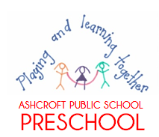
Ashcroft Public School Preschool Procedure
Sleep and rest for children
Reviewed: 2020 To be reviewed: 2021
Education and care services regulation/s | NSW Department of Education policy, procedure or guidelines
Regulation 168(2)(a)  Regulation 81 | The following department document can be accessed from the preschool section of the department’s website;  - Sleep and rest guidelines for department preschools (attached below)
Procedures:
Please refer to the department’s preschool sleep and rest guidelines below. In addition;
- After lunch each day, the children will be encouraged to select a quiet indoor activity; book browsing, puzzles, fine motor activities, drawing etc.

- During this time, half the lights will be turned off and children whose family have indicated they require a sleep will be encouraged to rest on their own pillow and sheet.

- During this period, relaxation music will also be played or one of the educators may guide the children in yoga or meditation.

- If a child falls asleep, they will be undisturbed. If the remainder of the group moves outside, one educator will remain indoors to supervise the sleeping child, or if clearly visible, the child will be watched through the window or open doors.

- At all times of the preschool day, a child may choose to rest in our indoor or outdoor cushioned areas.

- Our educators and families will use the drop off and collection periods to informally discuss a child’s sleep and rest requirements.

