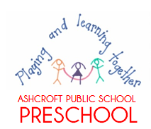
Ashcroft Public School Preschool Procedure
Water Safety
Reviewed: 2020 To be reviewed: 2021
Education and care services regulation/s | NSW Department of Education policy, procedure or guidelines
Regulation 168 (2)(a) | The following department policy can be accessed from the preschool section of the department’s website;  - Excursion Policy PD/2004/0010/V07
Procedures:
- Any water containers features brought into the preschool that could be drowning hazards will be appropriately covered or inaccessible to the children.
- Water activities will be closely supervised and the reservoir will be at children’s standing height only. There will be no climbing equipment near water play activities.
- Educators will closely supervise children when they are using water in their play or watering the garden.

- Educators will empty any water containers immediately at the end of the play session, particularly larger trough-style containers.

- As part of the morning outdoor safety check, before the children arrive, educators will check no rain water has pooled in containers overnight.

- A risk assessment will be conducted prior to any excursion taking place. If the venue has a body of water such as a lake or creek, the staff to child ratio will be increased.

