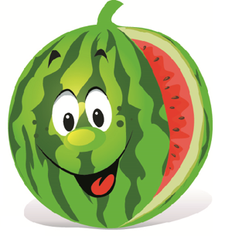

Hi Everyone!
I hope you all had a wonderful break. Yes we will be OPEN on the first day back of Term 1 (Wednesday). You are welcome to place lunch orders for your beautiful children like normal. As soon as I receive the class lists for 2020 I will update them on the My School Connect website for online lunch ordering. In the meantime if you are placing a lunch order online please select your child’s class from last year and write in the notes section what class your child will be in this year so it can be sent to the correct class, if you do not know then that is totally fine just ask your gorgeous kids to collect their lunch from the canteen counter at eating time.

We are super excited to get back in the canteen doing what we do best and that’s providing your beautiful children with yummy healthy food that’s made with lots of love. The everyday menu is still the same as last year and won’t change until it is winter time. My team and I will be creating eye catching nutritional food that the students will thoroughly enjoy! Everyday there will be fun and nutritional counter items that range from 50c to $2.50. We will also have weekly specials from week 3 that will change each week just to keep it interesting for our students so keep an eye on the board outside the canteen!

EFTPOS facilities, cash payments and online ordering through My School Connect will be available. Online ordering is a wonderful service to use if you want to avoid lining up during busy rush periods. My School Connect is a reliable online ordering service that has a service fee of 33c per order. Brooke’s Canteen does not receive this servicing fee, this goes to My School Connect. If parents do not wish to pay the 33c fee they are more than welcome to use my EFTPOS machine that has no fee and no minimum spending amount or you can pay with cash. Online ordering cut off time is 8am that morning and cut off time for orders placed at the canteen counter is 9am. To register for online ordering please head to www.myschoolconnect.com.au.

Lunch orders will be sent to the students classrooms however watermelon cups, custard cups, warm noodles and ice blocks need to be collected from the canteen by the student as these can spill and leak all through the lunch order baskets. If you have any requests or any dishes you would like added to the menu feel free to pop by the canteen and let us know! In the mean time you can follow our Facebook page called Brooke’s Canteen to see what food has been on offer each week.
Lots of love Brooke xxx

